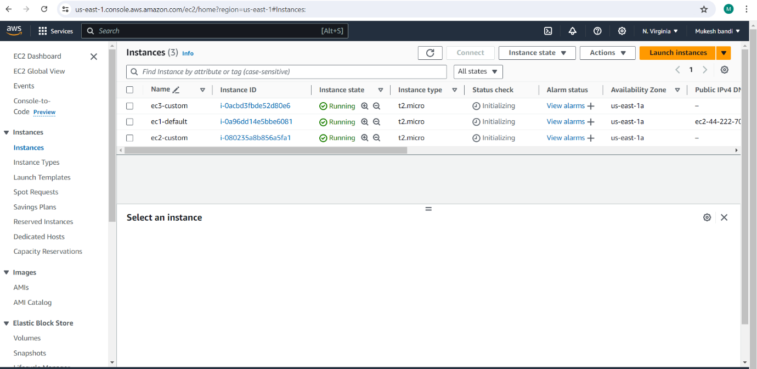

* Here I created the ec2 instance

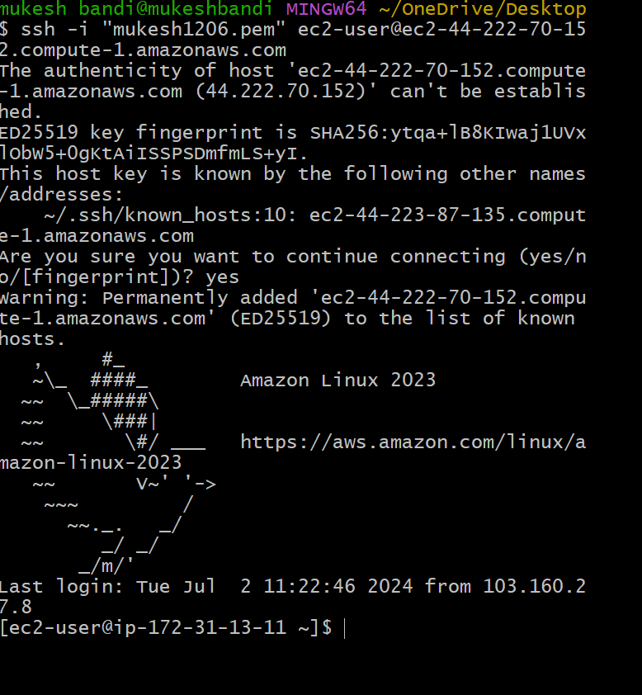

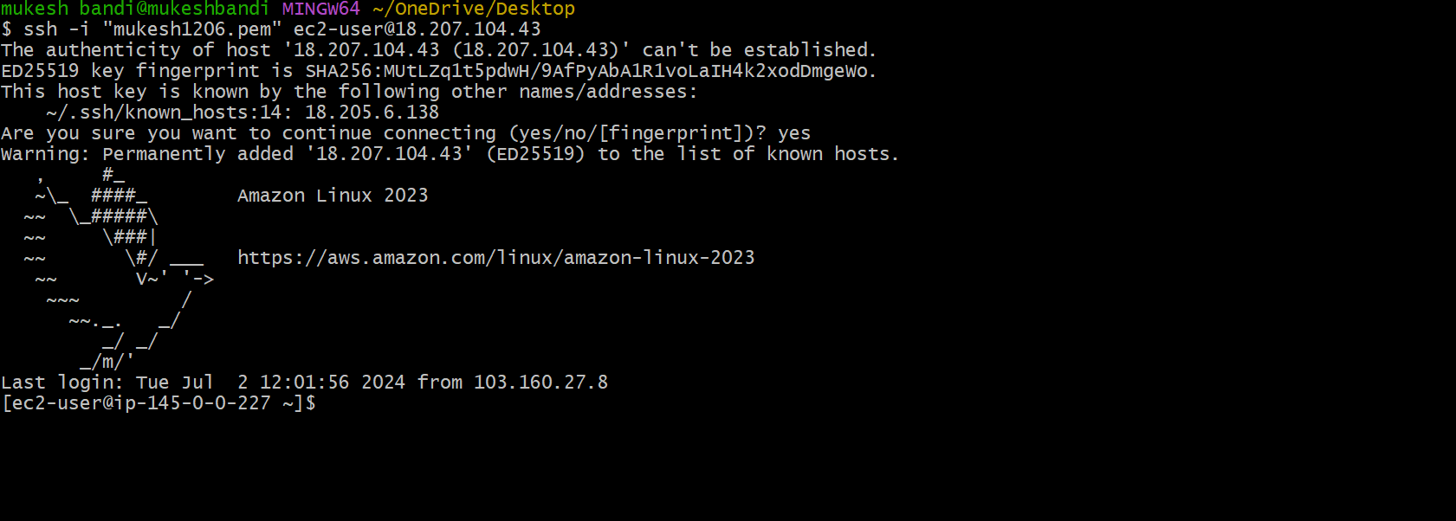

# 

* Here I launched the ec2 in git bash
* EFS

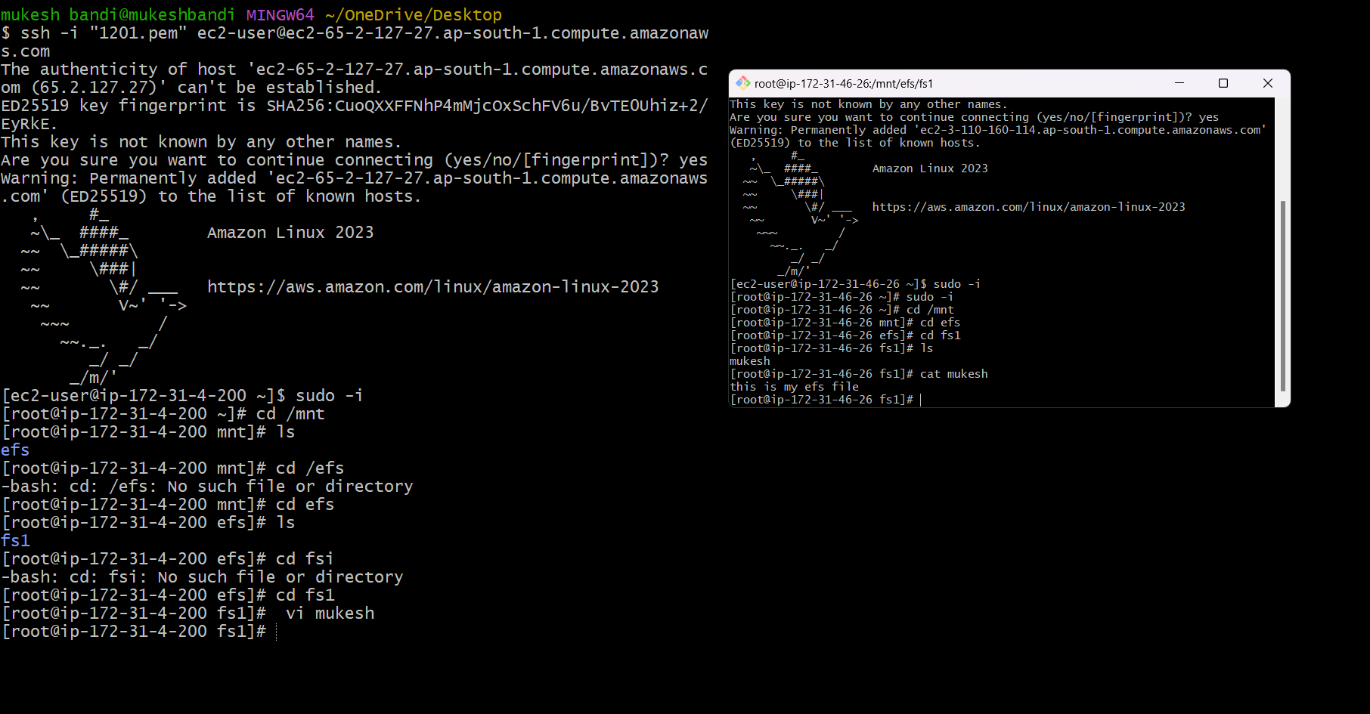

* Here I created the file system and security group attached to the two instance that I created in ec2
* Then I created the file in one instance
* That is visible in other instance also

* EBS

* Multiple EBS can be created to one instance
* If we create the instance in one availability zone(1A) then the EBS should be created in same availability zone(1A)
* So, one should not be connected to the multiple instance
* To know the EBS is attached to the ec2 ,we use the “LSBLK” command

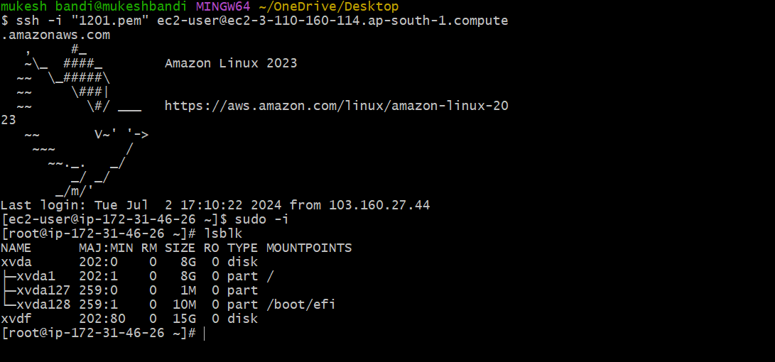

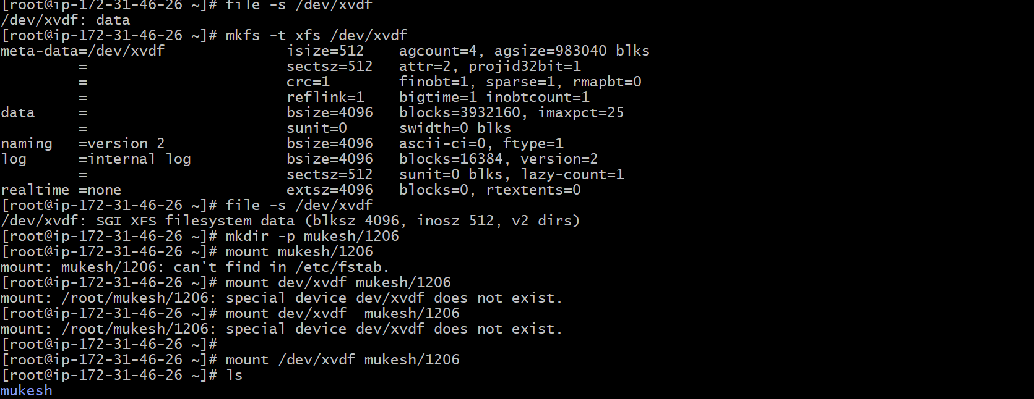

* To check the file system & create the file system we use above commands
* After that mount /dev/xvdf